1. Course Introduction

Cameron Pittman = Front-end course developer

60% of the top 100,000 websites use jQuery.

jQuery is a JS library, not a language on its own. Selectors and DOM navigation methods. Lots of quizzes incoming.

1. Why Does jQuery Exist?

jQuery is just a JS library. Not as performant, but just as functional. jQuery exists because manipulating the DOM with vanilla JS is not always easy. Focus on UX, not browser quirks.

1. Quiz: What is jQuery actually

Udacity uses jQuery. jQuery is a function and an object.

1. Money, Money, Money (the $)

The $ is mapped to the jQuery object. $ is faster and easier to type the jQuery.

1. How to Use the $

jQuery Collection is an array like object. Look into ajax.

1. Quiz: DOM Inspiration

DOM is a data structure much like a tree! Parents, children, and siblings.

1. How Is jQuery Included in a Page?

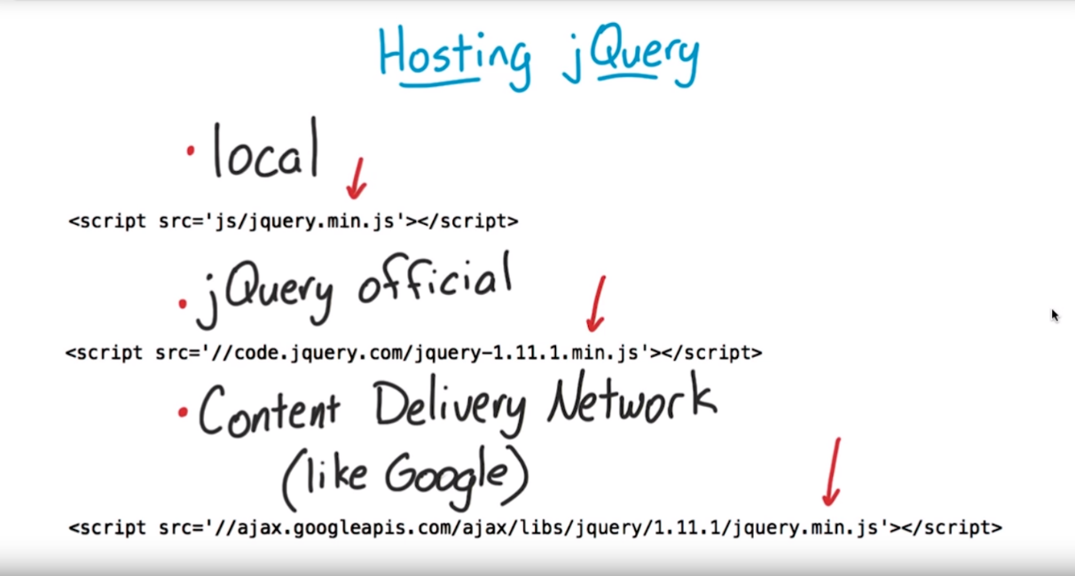

1. Quiz: Select by Tags

listElements = $(‘li’);

1. Quiz: Select by Classes Quiz

$(‘tag’) and $(‘.class’)

$(‘.article-item’)

1. Quiz: Select by IDs

nav = $('#nav');

console.log(nav);

1. Family Tree Revisited

Select specific elements of the DOM.

<http://api.jquery.com/category/traversing/>

1. Quiz: Filters Quiz

h1 = articleList.siblings(‘h1’);

kids = articleList.children();

parents = articleList.parents(‘div’);

1. High Five!

jQuery is all about making changes to the webpage.